Yesterday we had great results at the lab! We explored different kinds of exothermic reactions, measured the temperature vs time of all of them and organized ALL the data in a beautiful table. We thought about every detail! Titles, units, observations-everything was there!! We were so tired and proud, that we decided that we deserve a break at the sea shore in this summer hot day and meet in the afternoon, after renewing our energy.  When we opened our notebook, we were shocked to see that ALL our data was gone! The margins of the table were there, but the table was almost empty and some numbers could be vaguely noticed.  We called our Chemistry teacher and she asked us to try to write "the story of the table". | 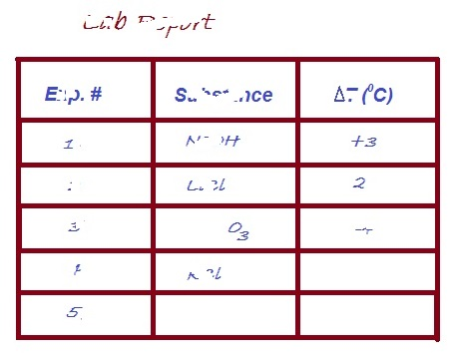
Engage
Task 1:  Task 2: | Suggest relevant observations or questions that need to be considered to resolve the mystery of the missing data, to write "the story of the table".  Suggest how to re-appear the missing data in the lab report that you received.
Explore
Task 1:  Task 2: | Ask for materials and equipment and try to make the ink reappear. Explore the behavior of the ink.  Describe what you did and what happened.
Explain
Task 1: | Hypothesize: How does the ink work?
Task 2: | Give a reasonable explanation for your hypothesis based on concepts related to energy transfer in chemical reactions.
Task 3: | Brainstorm with the class and explain how the ink works.

Evaluate
Extend
Task 1: Write five questions that arose while exploring the ink?

Task 2: Choose one of the questions that you would like to investigate regarding the "ink" and formulate this question clearly as an inquiry question?

Task 3: Clearly formulate a hypothesis that relates to the question that you chose to investigate. Give reasons for your hypothesis, based on correct and relevant scientific knowledge.

Task 4: Plan an experiment that will check your hypothesis.
• Detail all the steps of the experiment, including the control stage.
• List the equipment and materials needed on the equipment request form.
• Consult with the teacher and make changes if necessary.
• Submit the list of equipment and materials to the laboratory technician.
Evaluate
Task:
Prepare a lab report.
Draw a picture that "uses" the phenomena of the
disappearing/reappearing ink to express an idea.

