Today I brought a "love meter", I got it from a vendor at the flea market whom I've known for a couple of years. She claimed that "if someone is in love, the love meter will tell the truth. And if they aren't - nothing will happen. But be careful, sometimes people who do not truly love, try to press the love meter soooo hard that it breaks. But that won't change a thing. If you don't love, it just doesn't show any change!".  Does somebody in class want to try it? It is easy! | 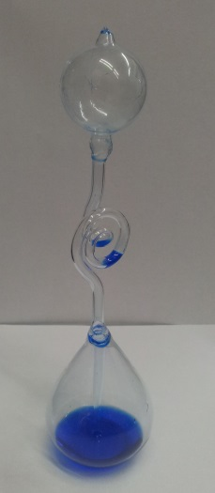
Engage
Task in front of the class: | Wrap the lower bowl of the love meter and think about something or someone you like.
Explore
In groups  Task 1:  Task 2: | Explore the behavior of the love meter  • Is there a difference if you lay the love meter on top of your palm, if you wrap it with your whole hand or if you place it in warm water?  Describe what you did and what happened. Take into consideration the structure of the love meter.
Explain
Task 1: | Hypothesize: How does the love meter work?
Task 2: | Give a reasonable explanation for your hypothesis based on the particle theory of matter.
Task 3: | Rub some alcohol or acetone on the top of the love-meter. Describe what happened.  Suggest an explanation.

Extend
Task 1: Pseudo-science is beliefs or claims that are presented as scientific but have no scientific backing.
- Do you think that the love meter is an example for pseudo-science?
- Think and bring up pseudo-scientific claims from everyday life and suggest how they might be tested scientifically.

Evaluate
Task:
Submit the answers to the tasks to your teacher.

