UNIVERSITY of TARTU : PROFILES teacher`s PORTFOLIO

About myself
My name is Evi Piirsalu. Since 1999 I work Nõo Basic School as a science teacher. I teach primarily in the following subjects: biology, geography, natural science and chemistry. I graduated from The University of Tartu and I have a master’s degree in geography.
My goal is to teach children to love and appreciate nature. I have participated with my students in several international projects: Comenius project such as 2008 -2010 Effective teaching in Maths, Science and Foreign Languages; 2004 -2007 Collaboration for Growing and Building and in Baltic Sea projects. International projects are important because they give possibility to students communicate with other nations. This allows students to learn more about the culture of other nations as well as the natural environment, it is particularly important to the understanding of global problems. Teachers have the opportunity to meet with colleagues from other countries and learn about different education systems.
I will try to offer students a variety of options that make learning interesting. I organize study visits to valuable natural places, which means the lessons to take place outside of the classroom. I introduce students to nature through various agencies: AHHAA Centre, University of Tartu Natural History Museum and Botanical Garden, Tartu Environmental Education Centre , CTC and nature centres in Tartu County. I use the programs offered by the museum in order to diversify the teaching. You might say that I'm on the right track, as evidenced by the year 2011: Natural and Science Prize 2011
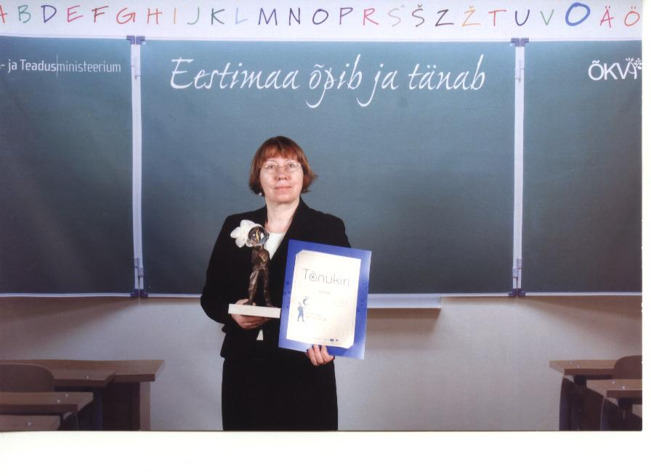

About the PROFILES modules
During my teaching I used five PROFILES modules:
- Coca-Cola myths and reality : This module was taught through different science lessons: biology, physics, geography and chemistry. Finally, the debate took place. Students had a real surprise that there was no truth given by the teachers and the principal had the ability to justify their choice. A portfolio of work in the course ready for what we estimated. Teachers were surprised that students did not know what the teacher portfolio represents how it is put together and why to do it. However, from an early age worksheets, etc. redundant in their portfolios.
- Which soap is best? Was used in March 2012. It took 3 lessons/hours. We used physics, chemistry and biology lesson. Each student prepared a leaflet with soaps characteristics and recommendation of what kind of soap to choose. We noticed that online communication has reduced the students vocabulary. For many students turned out to be difficult to describe the appearance of the object, its properties and results of tests and observations.
- Which soil is use for plants? In April of 2012. Eight grade.
Soil that seems so insignificant next to everyday problems, however, can help us cover the food table. We practiced setting research questions and hypotheses, which fit the question, which you can find the answer in the short term at school.
The aim was to examine how the composition and properties of the soil affect plant growth yield.
- What kind of food do we need?
Take place in 2013 spring. We used biology, physics and chemistry lessons. Once again, we received confirmation of the importance of motivating students in a vital story that scenario. Is a daily topical nutrition issues, and it involves plenty of legends. Students with practical work offered discoveries that meat products often contain more starch than meat, such as cooked sausages. It was also found that keeping the potato is not correct causes obesity. Substances in potatoes compared with the pasta, pastry and bread. Finally, each group presented its summary performance like a play, where the problem was based role

- Gym versus running. That is my first model which I used in classroom
Gym versus running. Have a trained person is durable, strong, smart and beautiful? Therefore I decided to give full description on how my teaching was going.

Module Description:
Abstract
This module introduces an understanding of the heart, the blood circulation and respiration system as per the Biology curriculum. Through inquiry learning in groups, students used data-loggers to acquire knowledge of the composition and function of the blood and the lungs, its constitution and the working of blood vessels and the breathing system and the composition of the air. They also learn about the effects of using the gym and running on the body systems of athletes and are placed .
Competences to promote:
1. Decide, based on sound arguments whether the humans have a responsibility to take care of their own health;
2. Appreciate that 'best for my heath' can have more than one interpretation and to suggest the most appropriate meaning in this context;
3. Plan an investigation, interpreting experimental instructions and carrying out an experimental procedure (to measure blood pressure, oxygen uptake, and pulse rate
4. Cooperating as a member of a group (in discussing/decision making, planning the experiment)
5. Communicating orally and by means of a written conclusion; writing an essay on changing exercise patterns.
6. Value a healthy lifestyle;
7. Analyse the impact of training on cardiovascular functions of the body.

Curriculum content:
Based school level: Training effect to cardiac, circulatory and respiratory function (helps to understand the training effect of cardiac, circulatory and respiratory functions).
Kind of activity: experimental work (planning investigation for impact of training to blood pressure, pulse rate and oxygen uptake, recovery rate of dependence of training), group discussion, writing the essay (My moving/exercise habits- to change or not).
Teaching-learning materials consist two parts: materials for teachers and materials for students.
Anticipated time: 4 - 5 lessons
WHY I CHOOSE THIS MODULE?
Grade nine students must study blood circulation system and they had already previous knowledge (they had studied mammal’s blood circulation system and human is mammal too) and I find it is a new way (approach) too teaches this issue. The second reason is in this material presented together biology, chemistry and physic and we (three teachers) decided to work collaborative. We shared tasks, made lessons plan and worked out plan how assess students (how exactly are we know what other teacher and students did in lesson).
PROBLEMS I FACED AND SOLUTIONS
Problems:
- Blood pressure /pulse measurement tool has only one in school
- We haven’t data readers (Vernier and Pasco).
- Parallel grades as lessons at same time, again we haven’t enough equipment.
- Scenario is not relevant for our students because they live in country side and the nearest gym is 30 km.
Solutions:
- We borrowed equipment from The University and neighbouring schools.
- Parallel grades didn’t’ study same issue, we changed lesson plan.
- We changed scenario.
WORK WITH STUDENTS
First stage … Was really hard for teacher
It was unexpected for student that they must do both ask and find answer themselves. Teacher didn’t say answers. It was tricky to reach students research issues and hypotheses. It seemed that the students made serious difficulty to find a suitable research question. We discussed science teachers and decided to put example in e-school system. We gave the students also general plan but in my estimates, students waiting detailed instructions. In order to work more wisely, the teacher had to intervene in their formation (each group will run into enterprising students).
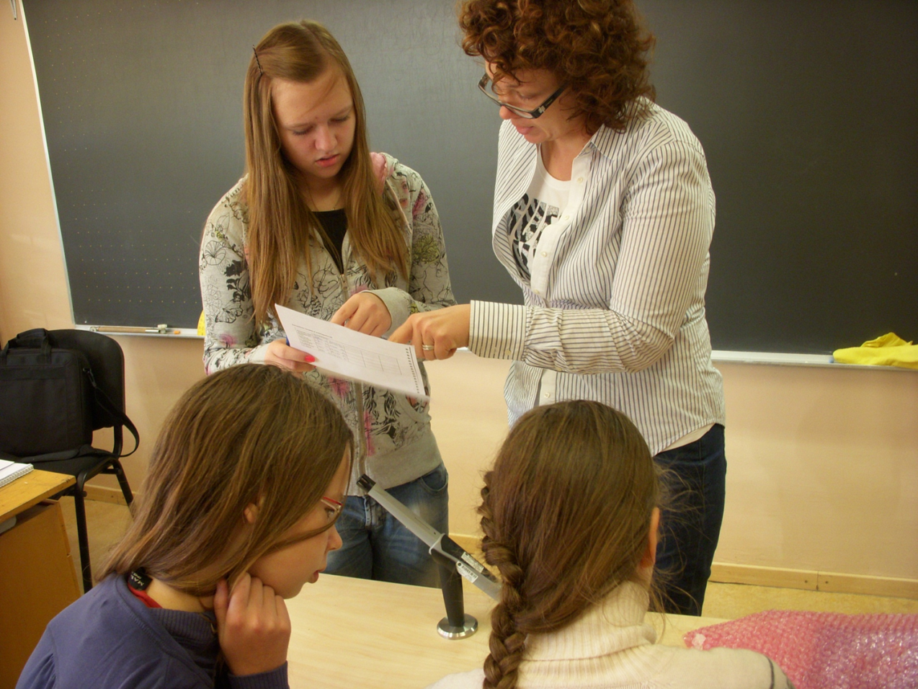

Second stage …. Requires students responsibility
Students didn’t prepare for the lesson; they hadn’t look information about the topic. In my opinion, students waited and hoped that it will make the teacher (as usually). Instead, they now had to go to the school library and look up the information anyway but we lost one lesson.
Students like ti do experiments but in both classes there were one group who lacked research question and hypothesis.
Students didn’t like to read the general plan; instead they tried to ask the teacher.

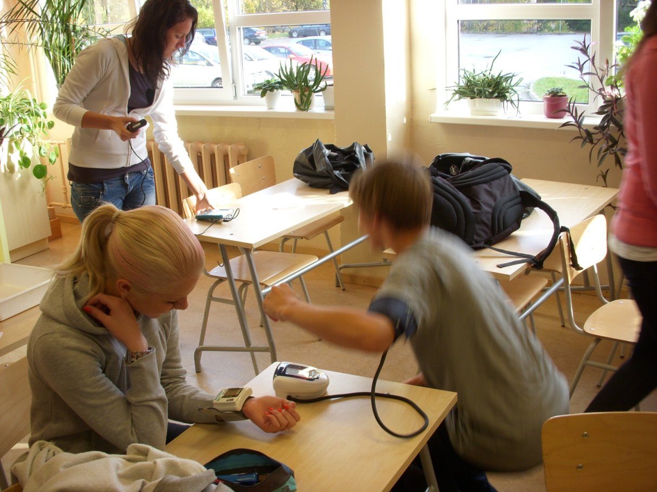

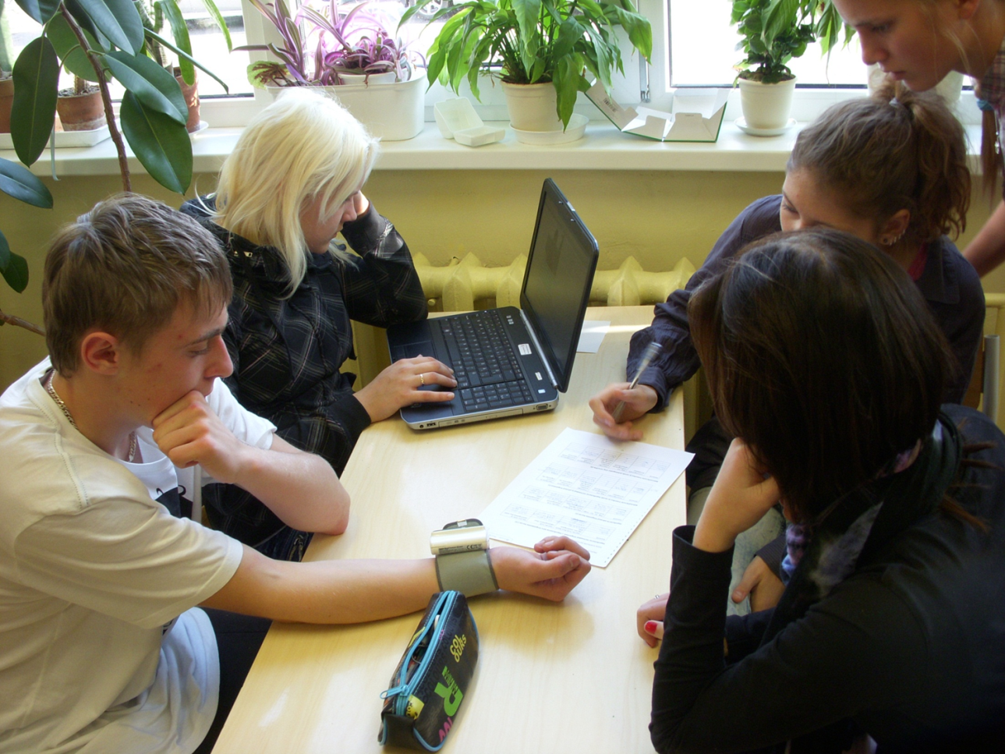
Students made presentations at the end of the second stage. In the picture you can see, students work in small groups, they measured pulse and blood pressure, one student (Mai) is absent. This group did your work very well; there is research question, results and conclusions.

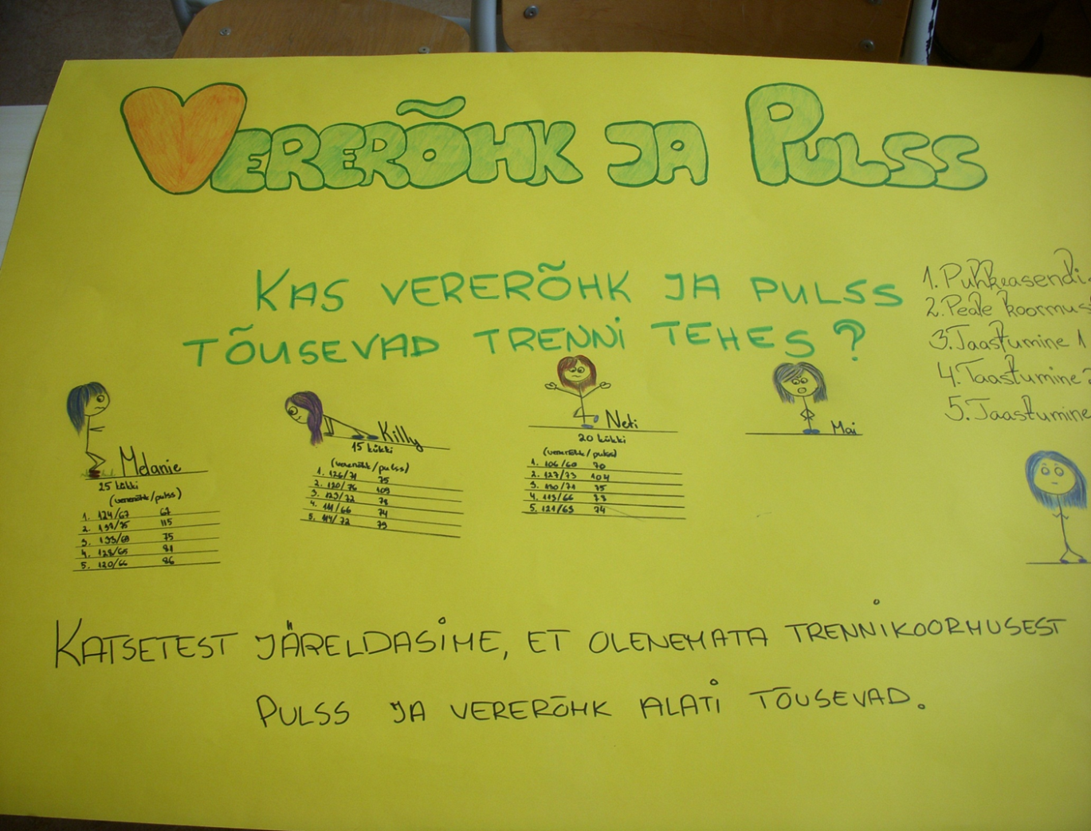

Third stage … the pleasure of the work done

In conclusion students write an essay of your movement’s habits. It took a lot of energy to explain to students that the essay. Students were not written an essay before in the natural science but results were good. Essays were related to the results of experiment the conclusions of their exercise habits and the need to modify their exercise habits or not.

Example from essay
Student A: In my opinion, every person should exercise to do to be happier and more energetic. It was not hard 2-3 times a week, instead of watching TV, go for a run to get a better feeling and to be healthier. (Marius)

Student B: Experiments proved that who trains the pulse was slower and faster recovery, so do the sports. (May)

FINALLY
Learned both sudents and teachers. What do we know?
- Working closely prescribed by the guidelines is convenient, but does not develop creative thinking . Detailed guide is suitable for measurement of physical quantities , and test performance for a specific purpose . This is one part of the study . Models helps to develop creativity of students.
- Group work is a result of the rich, if all members contribute. Therefore, they had to evaluate their own work and evaluate the work of other members of the group . Such an assessment was based on the formative assessment and was part of the grade. Myself and other 's not easy to assess . The end result is better placed to understand the principles of team work , the group as a whole , must all act . Modules help to develop to develop commucation , collaborative skills and resposibility.
- Estonian (our modules so the student if the teacher) is afraid of getting lost, wants to act as a very good level. Fear of failure shackles. Consequently, it is experienced by a lot of negative reviews . Initially, it took some time to take off the fear from failure . The investigator did not catch the first time, attempting to reach a perfect result. , Is a long-term research and numerous failures. What is important is the journey towards the goal . Therefore, the first module of the hardest and beyond went smoothly. Modules are student- centred and it helps reduce fears, students learn happily and not be afraid. Students learned to use each others help in learning.
- Protocol is extremely important in the whole process of fixation , observations, obtained additional information , test results , tables , graphs , found abnormalities , problems, drawings , photographs, videos. They are important for action reaseach and helps teacher reflect your own activities and analyse students results. Equally impoetant is that the students.
- We introduced modules and our results to colleagues in the school of experience performing exploratory learning methodology day , and the county science teachers network. The school did not have widespread positive response, it was found that it is time-consuming , a lot of extra work and created uncertainty. So teachers found that support is needed from headmaster, university and teacher trainers.

Appendix ( Module in Estonian as used by me including modifications)

I etapp: Loodusteaduslike probleemide leidmine igapäevaelulises situatsioonis.
STSENAARIUM
Jaan ja Jaak otsustasid joosta ümber järve. Alguses läks jooksmine ladusalt, nii et poisid said omavahel lobisedagi. Peale kahte kilomeetrit aga hakkas Jaan hingeldama ega suutnud enam Jaagu küsimustele vastata. Jaak aga õrritas, kuule kas sa oled nõrguke ja trenni ei teegi. Mis mees sinust nii kasvab ja milline tüdruk sind tahab?
Jaan vastas hingeldades, et tema käib jõusaalis ja tal on võimsad biitsepsid, mis on tüdrukutele meelepärased.
Jaak naeris selle peale: „ Lihas võib ju suur olla sellest pole mingit kasu. Süda jääb sul ikka nõrgaks.“
ARUTELU STSENAARIUMI PÕHJAL.
Näited arutelu teemadest: Millised eelised ja puudused on jooksmisel võrreldes jõusaalis treenimisega? Kui palju õpilastest käivad jõusaalis? Milline jõusaal on kõige populaarsem ja miks? Kui palju õpilastest käivad pidevalt jooksmas? Millised vabaõhu treenimise võimalused veel on olemas peale jooksmise? Kumb on õpilaste seas populaarsem kas jõusaalis treenimine või jooksmine ja miks? Kuidas treenimine mõjutab inimese organismi? Treeningu mõju vastupidavusele – kas treenitud inimene taastub kiiremini (pulss ja vererõhk taastuvad kiiremini. Kas treenitud inimese pulsisagedus on väiksem ja miks? Kas treenitud inimese kopsumaht on suurem ja miks? Kas treenitud inimene omastab hapnikku paremini ja miks? Kui treenitud inimene omastab hapnikku paremini, kas ta on siis ka targem? Kas treenitud inimene on ilusam (rüht, kõnnak, kehakaal)? Kas treenitud inimene on vähem haige (kas immuunsüsteem on tugevam)? Milline peaks olema tervislik treening? Millised on ületreenimise tagajärjed?
II etapp ÕPPIMINE
A:Info kogumine, vormistamine ja kaaslastele esitamine.
Rühmatöö (esitlus või poster)
- Treeningu mõju inimese füsioloogiale.
- Tervislik treening
- Ületreeningust tingitud ohud
B: Katseplaneerimine treeningu mõjust vererõhule, pulsisageduse intensiivsusele, hapniku omastamisele ja taastumisele peale füüsilist koormust.
Katse vahendid ja katsetingimused: Stopperkell, vererõhu ja pulsisageduse andur, (gaasilise hapniku või süsihappegaasi andur ja kilekotid hapnikuandurile), andmekoguja, arvuti.
Katse tulemuste vormistamine ja esitamine kaaslastele
III etapp: Loodusteadusliku info kasutamine uues situatsioonis. Essee „Minu liikumisharjumused – muuta või mitte“
Tunnijaotus plaan
- tund. Stsenaarium ja arutelu. Kas treening teeb vastupidavaks, tugevaks, ilusaks ja targaks? Treeningu erinevad liigid ja mõju inimese füsioloogiale. Loodusteaduslike probleemide leidmine. Rühmadeks jaotamine ja rühmatöö teema valimine ning rühmasiseste ülesannete jaotamine. ( eelteadmised südame-veresoonkonna ehitusest ja talitlusest, hingamiselundkonnast – võib teha mõistekaardi, õpetaja poolt juhitud vestlus). Kodune töö – info otsimine ja rühmatöö vormistamine).
- tund. Rühmatööde ettekanded. Katse planeerimine treeningu mõju kindlaks tegemiseks pulsi sageduse ja vererõhu määramiseks või hapniku omastamisele.
3.– 4. tund. Katse teostamine ja andmete vormistamine ning esitamine kaaslastele.
Kodune töö essee „Minu liikumisharjumused- muuta või mitte“.

Õpilase tööleht
Jõusaal versus jooksmine. Kas treenitud inimene on vastupidav, tugev, tark ja ilus?
Jaan ja Jaak otsustasid joosta ümber järve. Alguses läks jooksmine ladusalt, nii et poisid said omavahel lobisedagi. Peale kahte kilomeetrit aga hakkas Jaan hingeldama ega suutnud enam Jaagu küsimustele vastata. Jaak aga õrritas, kuule kas sa oled nõrguke ja trenni ei teegi. Mis mees sinust nii kasvab ja milline tüdruk sind tahab?
Jaan vastas hingeldades, et tema käib jõusaalis ja tal on võimsad biitsepsid, mis on tüdrukutele meelepärased.
Jaak naeris selle peale: „ Lihas võib ju suur olla sellest pole mingit kasu. Süda jääb sul ikka nõrgaks.“

• Sõnasta vähemalt kolm loodusteaduslikku probleemi, mis on seotud treeningu mõjuga inimesele.
• Moodustage 4-6 liikmelised rühmad. Leidke rühmas ühiselt üks loodusteaduslik probleem, mis on seotud treeningu mõjuga inimesele ja valmistage järgmiseks tunniks sellel teemal ettekanne.
• Planeerige rühmas katse, mille abil saab tõestada treeningu mõju inimese pulsisagedusele, vererõhule ja/või hapniku omastamisele. Sõnastage uurimisküsimus ja püstitage hüpotees. Mis on teie katses muutujaks?
Sooritage katse. Pöörake tähelepanu katsetulemuste vormistamisele (kasutage tabeli kuju).
Millised järeldused saate teha katse põhjal?
• Kirjutage essee teemal „Minu liikumisharjumused - muuta või mitte“.

Lisa õpetajale
Katse 1 . Kuidas mõjutab treenimine pulsisageduse ja vererõhu taastumist peale koormust?
1. Andurite kinnitamine. Vererõhuandur kinnitatakse klassikaliselt käe õlavarre osale.
2. Ühendage andur arvutiga ja käivitage vastav programm.
3. Proovige enne, et saaksite aru kuidas andur töötab. Proovige korduvalt, et saaksite hiljem kiiresti tegutseda.
4. Vaatluse läbiviimine – kinnitage andur esimesele katseisikule. Katseisik istub toolil võimalikult rahulikus olekus. Käivitage programm ja märkige üles saadud tulemused tabelisse.
5. Seejärel teeb katseisik 1,5 minuti jooksul niipalju kükke kui ta jõuab. Oluline on siinjuures kiirus.
6. Koormuse lõppedes tuleb teistel aidata katseisikule külge andur ja võimalikult ruttu mõõta vererõhk ja pulss.
7. Taastumise kindlakstegemiseks mõõtke samu näitajaid 1, 2, 3 … minuti möödudes. Tulemused kandke tabelisse.

Katse 2. Kuidas mõjutab treenimine hapniku omastamist?
1. Kinnitage hapnikuandurile terve kilekott (nii, et saaksite vahepeal lihtsasti kotti tuulutada).
2. Käivitage andmekogumine ja oodake kuni hapnikunäit on stabiliseerinud (PS valige mõõtühikuks %)
3. Esimeses katses tuleb igal katseisikul üks kord hingata koti sisse kopsudes olev õhk. Järgnevalt laske anduril mõõta kotis oleva õhu hapnikusisaldust vähemalt 2 minuti jooksul. Andmed kandke tabelisse.
4. Teises katses tuleb katseisikul hinge kinni hoida. Selles katses on vaja stopperit. Kella käivitades tõmbab katseisik sügavalt hinge ja hoiab seda kinni niikaua kui suudab, seejärel puhub katseisik kopsudest õhu kilekotti ning sulgeb kiirelt kotisuu. Järgnevalt laske anduril mõõta kotis oleva õhu hapnikusisaldust vähemalt 2 minuti jooksul. Andmed kandke tabelisse (ka hinge kinnihoidmise aeg).
5. Kolmandas katses tuleb hästi kiiresti hingata 30 sek jooksul umbes 30 korda (hingeldada). Viimase väljahingamisega hingata kopsudes olev õhk kotti. Tulemused kanda tabelisse.

Lisa õpetajale
Katse tulemuste vormistamise näidised.
Hapnikutarve normaalsel hingamisel. ( Hapnikutarve kiire hingeldamise korral.) (1)
Katseisik | Hapniku hulk õhus (katse alguses, sissehingatav õhk) | Hapniku hulk väljahingatavas õhus | Muutus sisse- ja väljahingatava õhu vahel

Hapnikutarve piiratud hingamise korral (1)
Katseisik | Aeg (s) kui hinge kinni hoiti | Hapniku hulk õhus (katse alguses, sissehingatav õhk) | Hapniku hulk väljahingatavas õhus | Muutus sisse- ja väljahingatava õhu vahel

Rühmaliikmete treenitus ja nende hapnikutarve normaalsel ja piiratud hingamisel.(1)
Katseisik | Treeningumaht  (h/nädalas) | Aeg, mil treeninguid on tehtud (kuud) | Treeningu kirjeldus  ( aeroobne treening, jõu treening jne.) | Hapnikutarve normaalsel hingamisel (%) | Hapnikutarve piiratud hingamisel (%)

Lisa õpetajale
Rühmaliikmete treenitus ja nende pulsisagedus ning vererõhk.(2)
Katseisik | Treeningumaht  (h/nädalas) | Aeg, mil treeninguid on tehtud (kuud) | Treeningu kirjeldus  ( aeroobne treening, jõu treening jne.) | Pulsisagedus ja vererõhk puhkeasendis | Pulsisagedus ja vererõhk peale koormust

Katseisikute vereõhk ja pulsisagedus (2)
Vererõhk/pulss
Katseisiku
nimi
puhkeasendis
Peale koormust
Taastumine
1. minut
Taastumine
2. minut
Taastumine
3. minut

